Project 9-1: Student Scores

User interface
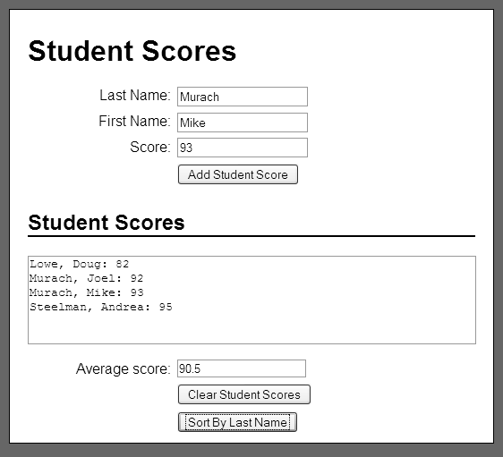

Operation
- This application stores the last name, first name, and score for one or more students and it calculates the average score for all of the scores that have been entered.
- When the user clicks on the Clear button, this application clears the score data from this application.
- When the user clicks on the Sort button, this application sorts the data in alphabetical order by last name.

Specifications
- The program should use one or more arrays to store the data.
- Assume that the user will enter valid data.

